Overview
This document has been prepared to define the relevant standards necessary for interconnecting the Phone with Bluetooth module (Host) and the HUD(Slave) on the basis of the Host. The Host transfers to the Slave information relating to direction, distance and other safe driving alerts from the map in accordance with the standards outlined in this document, and the Slave analyzes such information and displays driving information on the LCD.

Communication Method
Bluetooth
- HUD_BT Device F/W Ver : 1.1.0 (Apply)

Message Data Format

[ Phone(Host) → HUD(Slave) ]

HUD Display Message
Header
DATA
CS
$(0x24)
H(0x48)
Data(D1 ~ D34)
CS
- $ : Start Of Message (0x24)
- H : HUD Display Message (0x48)
- D1 – D234: HUD Data (34 Bytes)
- CS : Check sum, Calculates from Header to Data CS = ( $ + H + D1 + ….. + D34 )
- Length : 37Bytes( 1+1+34+1)
*) Zero-Checksum [1Byte] = ( $ + H + D1 + ….. + D34 )

D1 | Route Availability0x01: Route Available. 0x00: No Route Available | 1 Byte
D2 ~ D5 | Distance to First Turn (10m intervals) | 4 Bytes
D6 | Direction of First Turn (Refer to 5.1) | 1 Byte
D7 ~ D10 | Distance between First Turn and Second Turn | 4 Bytes
D11 | Direction of Second Turn (Refer to 5.1) | 1 Byte
D12~D15 | Distance to Speed Camera | 4 Bytes
D16~D19 | Speed Camera Limit | 4 Bytes
D20~D23 | Current Speed | 4 Bytes
D24~D27 | Distance to Destination | 4 Bytes
D28 | Unit of Current Speed & Speed Limit  0x00 : meter , 0x01: mile , 0x02 : dot[mile], 0x03 : feet | 1 Byte
D29 | Unit of distance to speed camera.  0x00 : meter , 0x01: mile , 0x02 : dot[mile], 0x03 : feet | 1 Byte
D30 | Unit of distance to destination.  0x00 : meter , 0x01: mile , 0x02 : dot[mile], 0x03 : feet) | 1 Byte
D31 | Unit of distance to 1st turn  (0x00 : meter , 0x01: mile , 0x02 : dot[mile], 0x03 : feet) | 1 Byte
D32 | Unit of distance to 2nd turn.  (0x00 : meter , 0x01: mile , 0x02 : dot[mile], 0x03 : feet) | 1 Byte
D33 | Phone Call or Text message  0x00 : None , 0x01 : Phone Call , 0x02 : SMS Message | 1 Byte
D34 | LDC OFF at the end of guidance  0x00 : LCD Off , 0x01 : LCD On | 1 Byte
- 0xFF : Indicates invalid data. (Not displayed)
- Distance Unit
- 0x00 : Meter ex) 11 => 11m, 199 => 199m
- 0x01 : Mile ex) 11 => 11mile, 155 => 155 mile
- 0x02 : Mile in decimal point ex) 1 => 0.1. 12 => 1.2mile 155 => 15.5 mile
- 0x03 : Feet unit ex) 528 => 528 feet

- Phone Call or Text message received:
0x00 : None
0x01 : Phone Call
0x02 : Text Message

HUD Setting Message
Header
DATA
CS
$(0x24)
S(0x53)
Data(D1 ~ D4)
CS
- $ : Start Of Message (0x24)
- S : HUD Setting Message (0x53)
- D1 ~ D4 : HUD Data (4 Bytes)
- CS : Check sum, Calculates from Header to Data
- Length : 7 Bytes( 1+1+4+1)

D1 | HUD Use 0x01:Yes, 0x00: No | 1 Byte
D2 | Brightness Control :  0x01: Auto brightness control with light sensor  0x00: Manual brightness control using the User interface | 1 Byte
D3 | Manual Brightness Level Settings: 0x01 - 0x06 | 1 Byte
D4 | Reserved | 1 Byte

Product Manufacturing Serial Number Request Message
Header
DATA
CS
$(0x24)
s(0x73)
Data(D1 ~ D4)
CS

- $ : Start of Message (0x24)
- s : Product Manufacturing Serial Number Request (0x73)
- D1~D4 : HUD Data (4 Bytes)
- CS : Check sum, Calculates from Header to Data
- Length : 7 Bytes( 1+1+4+1)

D1 | Product Manufacturing Serial Number Request : 0x83 | 1 Byte
D2 | Reserved | 1 Byte
D3 | Reserved | 1 Byte
D4 | Reserved | 1 Byte

3.1.4. HUD SW Upgrade Request Message
Header
DATA
CS
$(0x24)
U(0x55)
Data(D1 ~ D4)
CS
- $ : Start of Message (0x24)
- U : HUD SW Update Request Message (0x55)
- D1 ~ D4 : HUD Data (4 Bytes)
- CS : Check sum, Calculates from Header to Data
- Length : 7 Bytes( 1+1+4+1)

D1 | HUD SW Upgrade Request : 0x01 | 1 Byte
D2 | Reserved | 1 Byte
D3 | Reserved | 1 Byte
D4 | Reserved | 1 Byte

3.1.5 HUD SW Version Information Request Message
Header
DATA
CS
$(0x24)
V(0x56)
Data(D1 ~ D4)
CS
- $ : Start of Message (0x24)
- V : HUD SW Version Information Request Message (0x56)
- D1 ~ D4 : HUD Data (4 Bytes)
- CS : Check sum, Calculates from Header to Data
- Length : 7 Bytes( 1+1+4+1)

D1 | Request Information Type  0x01 : HUD SW Version Information  0x02 : HUD SW Build Date Information : 0x02 | 1 Byte
D2 | Reserved | 1 Byte
D3 | Reserved | 1 Byte
D4 | Reserved | 1 Byte

3.1.6 HUD Display Clear Message
Header
DATA
CS
$(0x24)
C(0x43)
Data(D1 ~ D4)
CS
- $ : Start of Message (0x24)
- C : HUD Display Clear Message (0x43)
- D1 ~ D4 : HUD Data (4 Bytes)
- CS : Check sum, Calculates from Header to Data
- Length : 7 Bytes( 1+1+4+1)

D1 | Request Information Type  0x00 : HUD Display On  0x01 : HUD Display Off | 1 Byte
D2 | Reserved | 1 Byte
D3 | Reserved | 1 Byte
D4 | Reserved | 1 Byte

[ HUD(Salve) → Phone(Host) ]

HUD Setting Value Request Message
Header
DATA
CS
$(0x24)
S(0x53)
Data(D1 ~ D4)
CS
- $ : Start of Message (0x24)
- S : HUD Setting Value Request Message (0x53)
- D1 ~ D4 : HUD Data (4 Bytes)
- CS : Check sum, Calculates from Header to Data
- Length : 7 Bytes( 1+1+4+1)

D1 | HUD Setting Value Request : 0x01 | 1 Byte
D2 | Reserved | 1 Byte
D3 | Reserved | 1 Byte
D4 | Reserved | 1 Byte
In response to this message, Host should response with [HUD Setting Message].

Response Message

[ HUD → Navi ]

Product Manufacturing Serial Number Response Message [ex) IM00000001 (10Bytes) ]
Header
DATA
CS
$(0x24)
s(0x73)
Data(D1 ~ D10)
CS

Header | Start of Message : $ (0x24) | 1 Byte
Req Msg | Request Message : s (0x73) | 1 Byte
D1 | HUD Serial Setting Value Response : I (0x49) | 1 Byte
D2 | HUD Serial Setting Value Response : M (0x4D) | 1 Byte
D3 ~ D10 | Serial Number (0x30 0x30 0x30 0x30 0x30 0x30 0x30 0x31) | 8 Bytes
CS | Check Sum | 1 Byte

4.1.2 HUD SW Version Information Response Message [ ex) V1.0.0 2014.08.22 (17Bytes)]
Header
DATA
CS
$(0x24)
V(0x56)
Data(D1 ~ D17)
CS
Header | Start of Message : $ (0x24) | 1 Byte
Req Msg | Request Message : V (0x56) | 1 Byte
D1 ~ D17 | HUD firmware version info Response : ex) V1.0.0 2014.08.22  - Include SPACE and Dot character. | 17 Bytes
CS | Check Sum | 1 Byte

4.1.3 HUD SW Version Build Date Info Response Message ex) Aug 13 2014 14:17:07 (20Bytes)
Header
DATA
CS
$(0x24)
s(0x49)
Data(D1 ~ D20)
CS
Header | Start of Message : $ (0x24) | 1 Byte
Req Msg | Request Message : I (0x49) | 1 Byte
D1 ~ D20 | HUD firmware build date info Response : ex) Aug 13 2014 14:17:07  - Includes SPACE and Dot character. | 20 Bytes
CS | Check Sum | 1 Byte

Turn Information

Direction Information
Index | Code | Description | Image
1 | 0x00 | Go Straight | 1
2 | 0x01 | Turn Right in the 1 o’clock Direction | 2
3 | 0x02 | Turn Right in the 2 o’clock Direction | 2
4 | 0x03 | Turn Right | 3
5 | 0x04 | Turn Right in the 4 o’clock Direction | 4
6 | 0x05 | Turn Right in the 5 o’clock Direction | 4
7 | 0x06 | Turn Left in the 7 o’clock Direction | 5
8 | 0x07 | Turn Left in the 8 o’clock Direction | 5
9 | 0x08 | Turn Left | 6
10 | 0x09 | Turn Left in the 10 o’clock Direction | 7
11 | 0x0A | Turn Left in the 11 o’clock Direction | 7
12 | 0x0B | U-turn to Right | 8
13 | 0x0C | U-turn to Left | 9
14 | 0x0D | At the Roundabout, Take the Exit in the 1 o’clock Direction | 10
15 | 0x0E | At the Roundabout, Take the Exit in the 2 o’clock Direction | 10
16 | 0x0F | At the Roundabout, Take the Exit in the 3 o’clock Direction | 11
17 | 0x10 | At the Roundabout, Take the Exit in the 4 o’clock Direction | 12
18 | 0x11 | At the Roundabout, Take the Exit in the 5 o’clock Direction | 12
19 | 0x12 | At the Roundabout, Take the Exit in the 6 o’clock Direction | 13
20 | 0x13 | At the Roundabout, Take the Exit in the 7 o’clock Direction. | 13
21 | 0x14 | At the Roundabout, Take the Exit in the 8 o’clock Direction. | 13
22 | 0x15 | At the Roundabout, Take the Exit in the 9 o’clock Direction | 14
23 | 0x16 | At the Roundabout, Take the Exit in the 10 o’clock Direction. | 15
24 | 0x17 | At the Roundabout, Take the Exit in the 11 o’clock Direction. | 15
25 | 0x18 | At the Roundabout, Take the Exit in the 12 o’clock Direction. | 16
26 | 0x19 | Departure | 0xFF
27 | 0x1A | Destination | 17
28 | 0x1B | Intermediate Destination | 0xFF
29 | 0x1C | P Turn | 18
30 | 0x1D | Rest (Service) Area | 19
31 | 0x1E | Drowsiness shelter | 20
32 | 0x1F | Tollgates | 21
32 | 0x20 | Fork-left | 22
33 | 0x21 | Fork-right | 23
34 | 0x22 | Ramp-left | 24
35 | 0x23 | Ramp-right | 25
36 | 0x24 | Keep-left | 26
37 | 0x25 | Keep-right | 27
38 | 0x26 | Roundabout-left | 28
39 | 0x27 | Roundabout-right | 29
40 | 0x28 | Roundabout-straight | 30
41 | 0x29 | Merge | 31
42 | 0x2A | SMS_ Message | 32
43 | 0x2B | Phone Calling | 33
44 | 0x2C | Ferry | 34(0xFF)
45 | 0x2D | Researching State | 35
46 | 0x2E | Rotary Left | 36
47 | 0x2F | Rotary Right | 37
48 | 0x30 | At the Roundabout, Take the Exit in the 10 o’ clock Direction. | 38
49 | 0x31 | At the Roundabout, Take the Exit in the 11 o’ clock Direction. | 38
50 | 0x32 | At the Roundabout, Take the Exit in the 9 o’clock Direction | 39
51 | 0x33 | At the Roundabout, Take the Exit in the 7 o’ clock Direction | 40
52 | 0x34 | At the Roundabout, Take the Exit in the 8 o’ clock Direction. | 40
53 | 0x35 | At the Roundabout, Take the Exit in the 4 o’ clock Direction | 41
54 | 0x36 | At the Roundabout, Take the Exit in the 5 o’ clock Direction. | 41
55 | 0x37 | At the Roundabout, Take the Exit in the 3 o’clock Direction | 42
56 | 0x38 | At the Roundabout, Take the Exit in the 1 o’ clock Direction | 43
57 | 0x39 | At the Roundabout, Take the Exit in the 2 o’ clock Direction. | 43
58 | 0x3A | At the Roundabout, Take the Exit in the 12 o’clock Direction | 44
59 | 0x3B | P Turn | 45
- 0xFF : Indicates invalid data. (Not displayed)
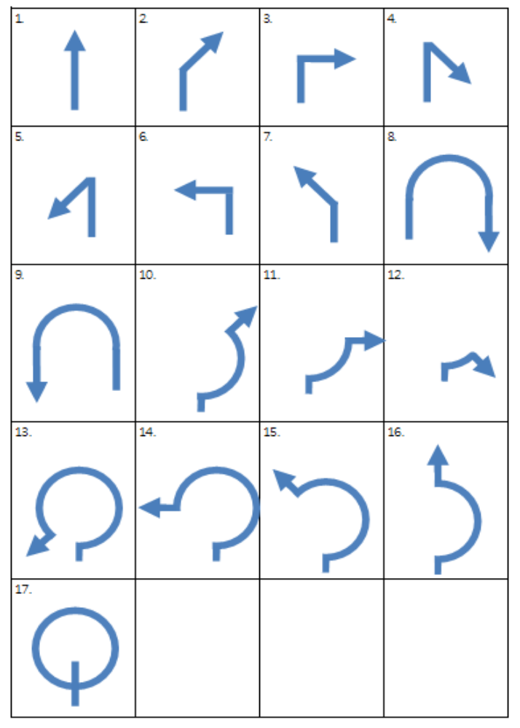
18 | 19 | 20 | 21
22 | 23 | 24 |  | 25
26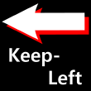 | 27 | 28 |  | 29
30 | 31 | 32 |  | 33
34  Ferry | 35  Researching | 36  Rotary Left |  | 37  Rotary Right
38   | 39   | 40   |  | 41  
42   | 43   | 44   |  | 45

Index | Code | Description | Image
1 | 0x80 | Enter Overpass Straight Ahead | 1
2 | 0x81 | Enter Overpass on the Right | 2
3 | 0x82 | Enter Overpass on the Left | 3
4 | 0x83 | Underpass | 4
5 | 0x84 | Lane to the Right of Overpass Entrance | 5
6 | 0x85 | Lane to the Left of Overpass Entrance | 6
7 | 0x86 | Lane to the Right of Underpass Entrance | 7
8 | 0x87 | Lane to the Left of Underpass Entrance | 8
9 | 0x88 | Right Lane | 9
10 | 0x89 | Left Lane | 10
11 | 0x8A | Enter Highway Straight Ahead | 9
12 | 0x8B | Enter Highway to the Right | 1
13 | 0x8C | Enter Highway to the Left | 11
14 | 0x8D | Enter Expressway Straight Ahead | 9
15 | 0x8E | Enter Expressway to the Right | 10
16 | 0x8F | Enter Expressway to the Left | 11
17 | 0x90 | Exit Highway to the Right | 10
18 | 0x91 | Exit Highway to the Left | 11
19 | 0x92 | Exit Expressway to the Right | 10
20 | 0x93 | Exit Expressway to the Left | 11
21 | 0x94 | Turn Left at the Junction | 12
22 | 0x95 | Straight Ahead at the Junction | 13
23 | 0x96 | Turn Left at the Junction | 14
24 | 0x97 | Tunnel | 15
25 | 0x98 | Enter Underpass on the Right
26 | 0x99 | Enter Underpass on the Left

